1. Store 15 integer values in an ArrayList and remove all duplicate elements without using another collection

import java.util.ArrayList;
import java.util.Scanner;

public class RemoveDuplicates {
public static void main(String[] args) {
Scanner sc = new Scanner(System.in);

ArrayList<Integer> list = new ArrayList<>();

System.out.println("Enter 15 integer values:");

for (int i = 0; i < 15; i++) {
list.add(sc.nextInt());
}

for (int i = 0; i < list.size(); i++) {
for (int j = i + 1; j < list.size(); j++) {
if (list.get(i).equals(list.get(j))) {
list.remove(j);
j--;
}
}
}

System.out.println("ArrayList after removing duplicates:");
System.out.println(list);

sc.close();
}
}

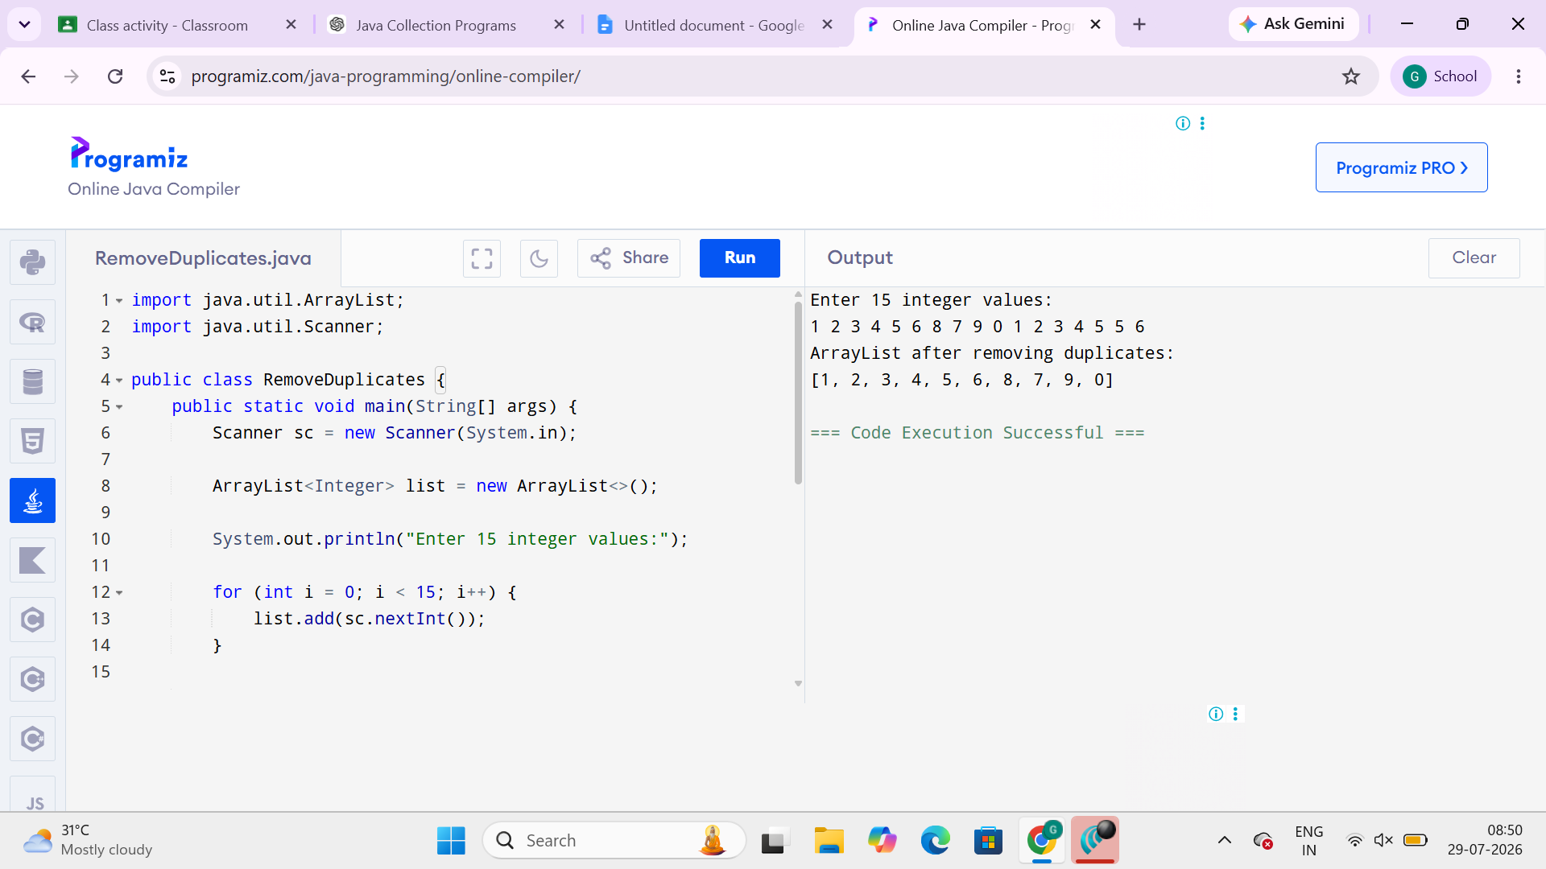

2. Store employee IDs in a LinkedList and display them in both forward and reverse order
import java.util.LinkedList;
import java.util.Scanner;
import java.util.Iterator;

public class EmployeeLinkedList {
public static void main(String[] args) {
Scanner sc = new Scanner(System.in);

LinkedList<Integer> employeeIDs = new LinkedList<>();

System.out.print("Enter number of employee IDs: ");
int n = sc.nextInt();

System.out.println("Enter Employee IDs:");

for (int i = 0; i < n; i++) {
employeeIDs.add(sc.nextInt());
}

System.out.println("\nEmployee IDs in Forward Order:");
for (Integer id : employeeIDs) {
System.out.println(id);
}

System.out.println("\nEmployee IDs in Reverse Order:");
Iterator<Integer> itr = employeeIDs.descendingIterator();

while (itr.hasNext()) {
System.out.println(itr.next());
}

sc.close();
}
}
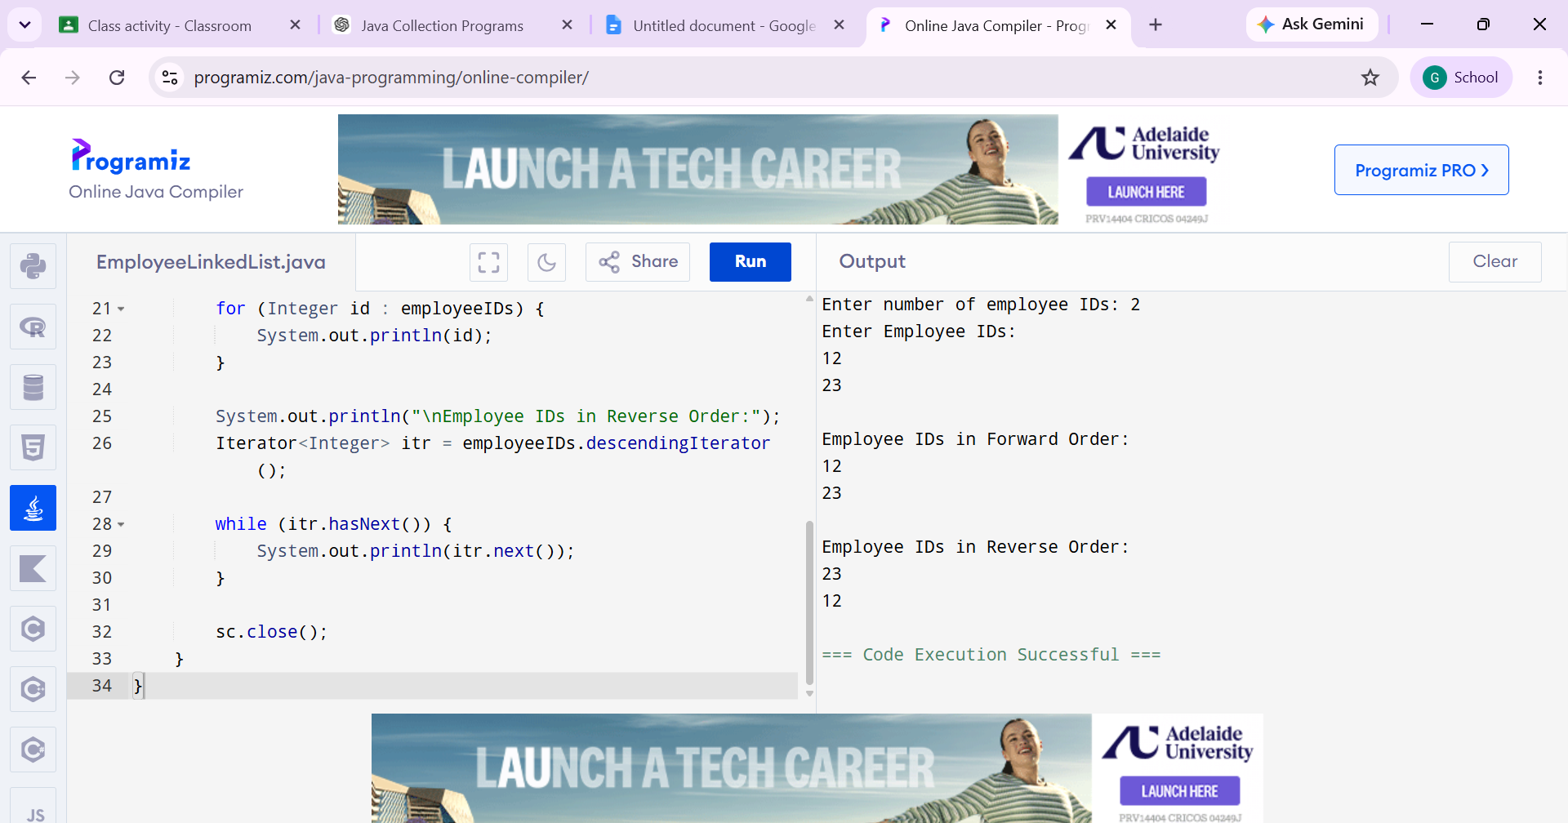

3. Store email IDs entered by the user in a HashSet. Display only unique email IDs and count the total unique entries
import java.util.HashSet;
import java.util.Scanner;

public class UniqueEmails {
public static void main(String[] args) {
Scanner sc = new Scanner(System.in);

HashSet<String> emails = new HashSet<>();

System.out.print("Enter number of email IDs: ");
int n = sc.nextInt();
sc.nextLine();

System.out.println("Enter Email IDs:");

for (int i = 0; i < n; i++) {
emails.add(sc.nextLine());
}

System.out.println("\nUnique Email IDs:");
for (String email : emails) {
System.out.println(email);
}

System.out.println("\nTotal Unique Email IDs: " + emails.size());

sc.close();
}
}
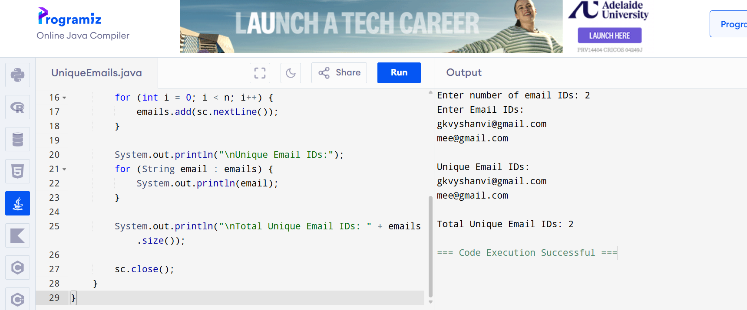

4. Count the frequency of each word in a paragraph using a HashMap
import java.util.HashMap;
import java.util.Map;
import java.util.Scanner;

public class WordFrequency {
public static void main(String[] args) {
Scanner sc = new Scanner(System.in);

System.out.println("Enter a paragraph:");
String paragraph = sc.nextLine();

paragraph = paragraph.toLowerCase();
paragraph = paragraph.replaceAll("[^a-zA-Z0-9 ]", "");

String[] words = paragraph.split("\\s+");

HashMap<String, Integer> map = new HashMap<>();

for (String word : words) {
if (map.containsKey(word)) {
map.put(word, map.get(word) + 1);
} else {
map.put(word, 1);
}
}

System.out.println("\nWord Frequencies:");

for (Map.Entry<String, Integer> entry : map.entrySet()) {
System.out.println(entry.getKey() + " : " + entry.getValue());
}

sc.close();
}
}
